Noise Pollution Monitoring

Program :

#include <LiquidCrystal_I2C.h>

LiquidCrystal_I2C lcd(0x27, 16, 2);

float flamelevel = 0;

#define greenLED 7

#define redLED 2

const int minSurvive = 15;

const int idleLow = 20;

onst int idleTarget = 30;

const int firingLow = 70;

const int firingHigh = 90;

void setup() {

  lcd.init();

  lcd.clear();

  lcd.backlight();

**Serial**.begin(9600);

  pinMode(greenLED, OUTPUT);

  digitalWrite(greenLED, LOW);

  pinMode(redLED, OUTPUT);

  digitalWrite(redLED, LOW);

}

void loop() {

  float analogValue = analogRead(A0);

**Serial**.print("Sensor RAW: ");

**Serial**.println(analogValue, 0);

  flamelevel = map(analogValue, 0, 1024, 100, 0);

**Serial**.print(flamelevel, 0);

**Serial**.println("%");

  lcd.setCursor(0, 0);

  lcd.print(F("Flame: "));

  if (flamelevel >= firingHigh) {

    lcd.print("Full Fire");

    digitalWrite(greenLED, HIGH);

    digitalWrite(redLED, LOW);

    delay(300);

    digitalWrite(greenLED, LOW);

  }

  if ((flamelevel >= firingLow) && (flamelevel < firingHigh)) {

    lcd.print("Firing   ");

    digitalWrite(greenLED, HIGH);

    digitalWrite(redLED, LOW);  }

  if ((flamelevel < firingLow) && (flamelevel > idleLow) ) {

    lcd.print("Idle fire ");

    digitalWrite(redLED, HIGH);  }

Sensor :

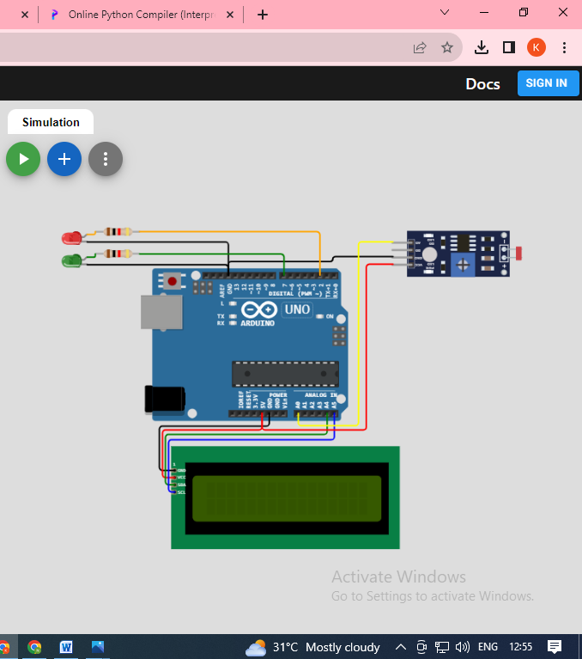

Output :

